**Api Testing Project**

**Project Name: Public REST API Testing using Postman**

**Tester Name: Ayesha Umer**

**Tool Used: Postman**

**1️ .Project Objective**

The objective is to test public REST APIs using Postman and validate their responses with test scripts, covering CRUD operations.

**2. API Information**

| **API Name** | **URL** |
| --- | --- |
| Reqres API | <https://reqres.in/> |

**3️ .Test Scenarios**

| **#** | **Test Case** | **Method** | **Endpoint** |
| --- | --- | --- | --- |
| 1 | Get list of users | GET | /api/users?page=2 |
| 2 | Create user | POST | /api/users |
| 3 | Update user | PUT | /api/users/2 |
| 4 | Delete user | DELETE | /api/users/2 |

**4️ .Test Results Summary**

| **Test Case** | **Expected Result** | **Actual Result** | **Status** |
| --- | --- | --- | --- |
| GET Users | 200 OK & User List | As Expected | Pass |
| Create User | 201 Created | As Expected | Pass |
| Update User | 200 OK | As Expected | Pass |
| Delete User | 204 No Content | As Expected | Pass |

**5️ . Request/Response**

* **GET Users Example**

**Request:**  
GET https://reqres.in/api/users?page=2

**Response:**

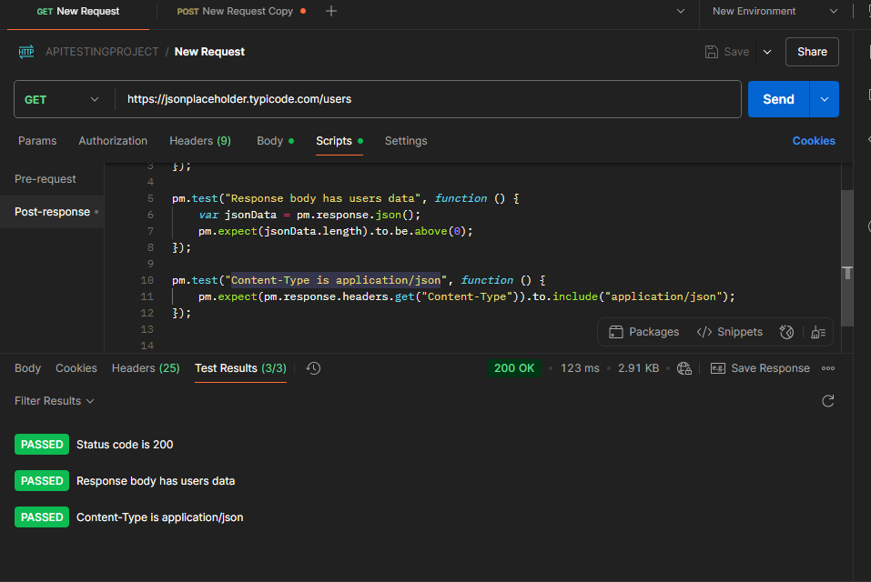

* **POST Create User Example**

**Request Body:**

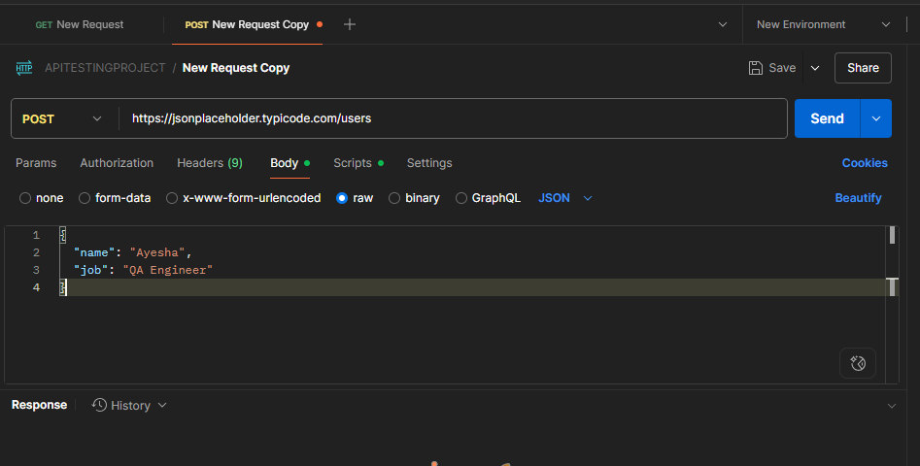

**Response:**

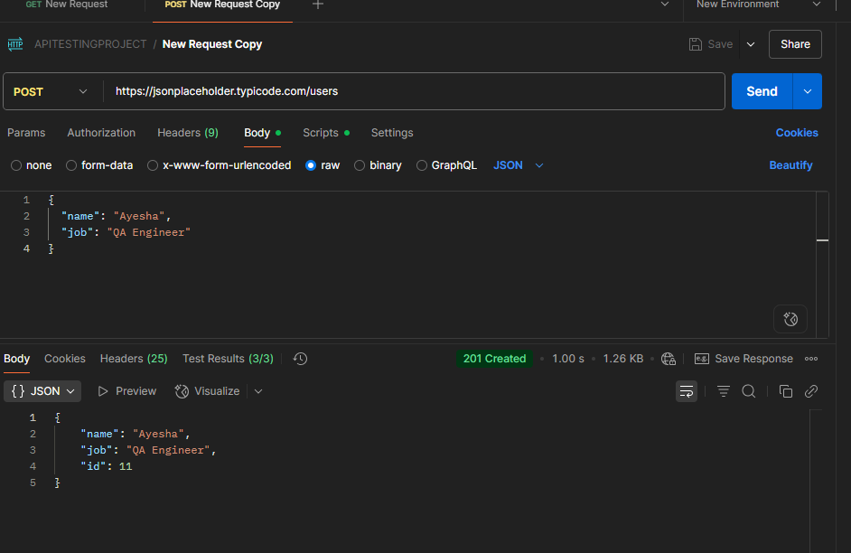

* **Edit Users**

**Request:**  
GET https://reqres.in/api/users?page=2

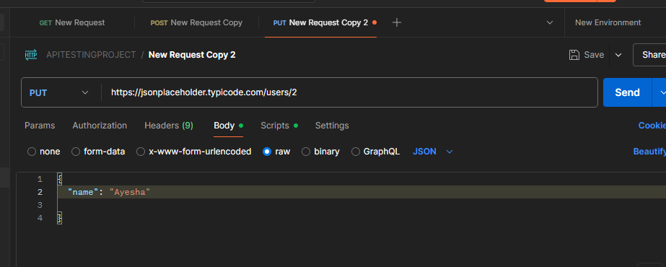

**Response**

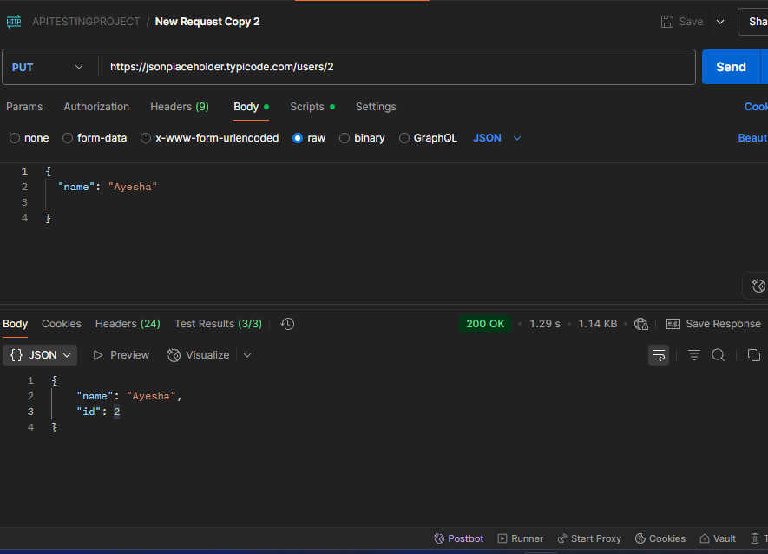

* **Delete Users**

**Request**

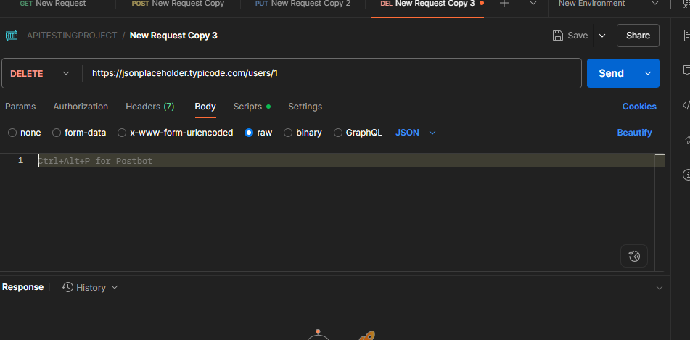

**Response**

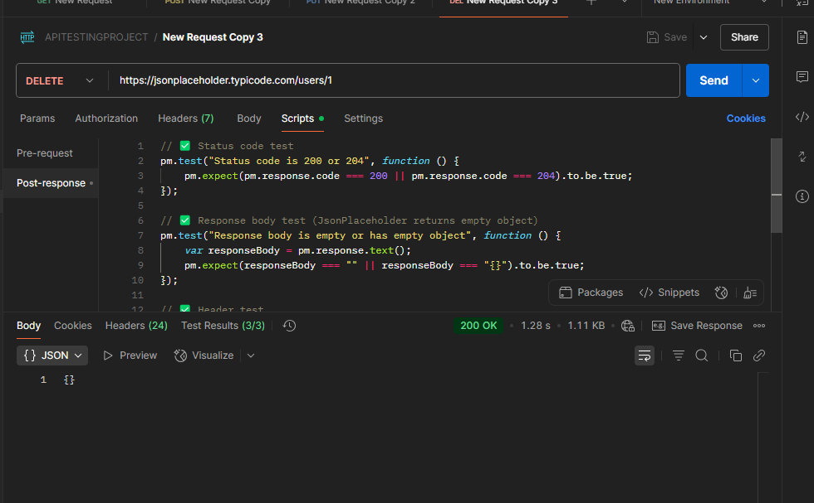

To verify the result after given invalid id.

